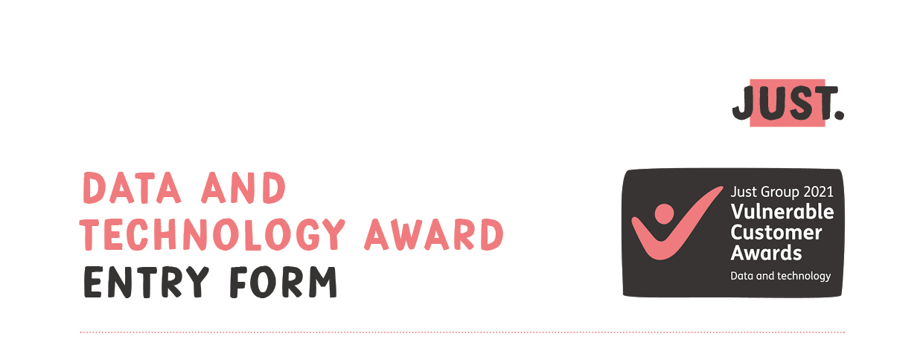

This category recognises the best use of data and technology to advance the customer vulnerability agenda.
Tell us how you’ve used your existing client data, or how you’ve gathered and stored new data to enable, highlight or monitor better support for vulnerable customers.
Tell us how you’ve used technology to identify or support clients experiencing vulnerability.
We’re looking for practical uses of data. These can be simple steps to segment clients or highlight potential risks – you don’t need to have created a new piece of artificial intelligence to win this award.
There will be three awards: Winner and two Highly Commended.
How to enter
- Please provide your CONTACT DETAILS and if you are happy to give us permission to use the entry information you provide for publicity purposes, check the PUBLICITY PERMISSION box.
- Use the YOUR ENTRY DETAILS box to tell us why you should win this award. Maximum 800 words please and no additional attachments.
- Email the completed entry form to VulnerabilityAwards@wearejust.co.uk
by Friday 30 July 2021.
- Entries will be assessed by a panel of expert judges and the results will be announced in September. The decision of the judges is final.

Contact details
*mandatory fields
First name* |  |  | Surname*
Email address* |  |  | Tel no*
Company name* |  |  | Job title*
Website*
Company FCA number (if applicable)
Company Twitter account
Company LinkedIn account

Publicity permission
I allow Just Group to make use of the submission information I have provided in entering the Just Group 2021 Vulnerable Customer Awards for publicity and marketing communications associated with the awards scheme, for example announcing and promoting award winners, as well as other Just Group communications.
Tips from the judges
- Use plain English and make your submission interesting. Tell an engaging story and don’t forget the human element.
- Where you can demonstrate your progress with evidence, hard data, number of colleagues, time saved,
number of clients, then add these into your submission.
- Don’t exceed the word count. You have a maximum of 800 words to make your case. Don’t add any additional attachments, the judges will only read your 800 words when making their assessments.
Your entry details
- Please use the box below to provide the information requested above and tell us why you should win
this award.
- Remember: the limit is 800 words and this entry form should be emailed to VulnerabilityAwards@wearejust.co.uk by Friday 30 July 2021.

How to count the words in your entry: enter your text in the box below, highlight it all and the wordcount will
be shown at the bottom of your screen on the left hand side.

